Overview of relational database management systems (DBMSs)

Data management: be used to capture, store, retrieve, analyze, present and interpret (large amount of) data

Ride sharing: an example of an application area where data plays a central role

**Database**: an organized collection of related data, usually stored on disk

* Important data
* Shared
* Secured
* Well-designed (minimal redundancy)
* Variable size

**Database Management System (DBMS)**: a software system designed to store and manage databases

Usages:

* Maintain integrity (integrity constraints)
* Control redundancy
* Create, modify, and query a database
* Provide support for decision making
* Control access

Different user groups may have different access privileges (create/ alter, update, and retrieve), which are controlled through DBMS security sub-system, through the use of accounts & passwords

* Casual users – may not have access to confidential data
* Parametric users – may be given update access, but are generally not allowed to change the structure of data
* Database administrators (DBAs) – generally have highest privileges, create user accounts and enforce restrictions
* Permit concurrent/simultaneous access (multiusers)
* Provide loading, backup, and recovery

【NOT the function of DBMS: design the database to be used】

Steps of **Conceptual database design (Entity-Relationship Model/ ER diagram)**:

1. Identify the ‘Universe of Discourse’ (UoD)/ ‘mini-world’
2. Convert the UoD to a conceptual schema, which can be captured by a database

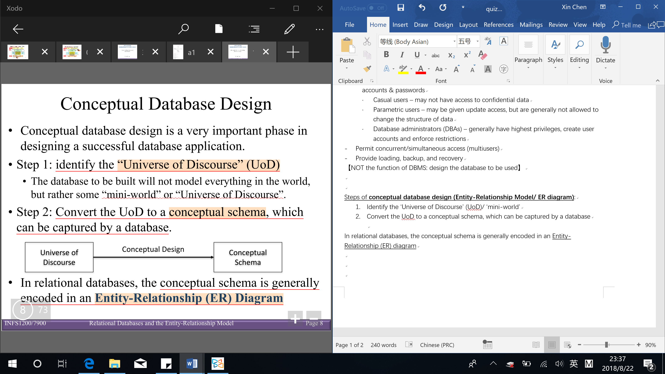

In relational databases, the conceptual schema is generally encoded in an Entity-Relationship (ER) diagram

Danger of modelling:

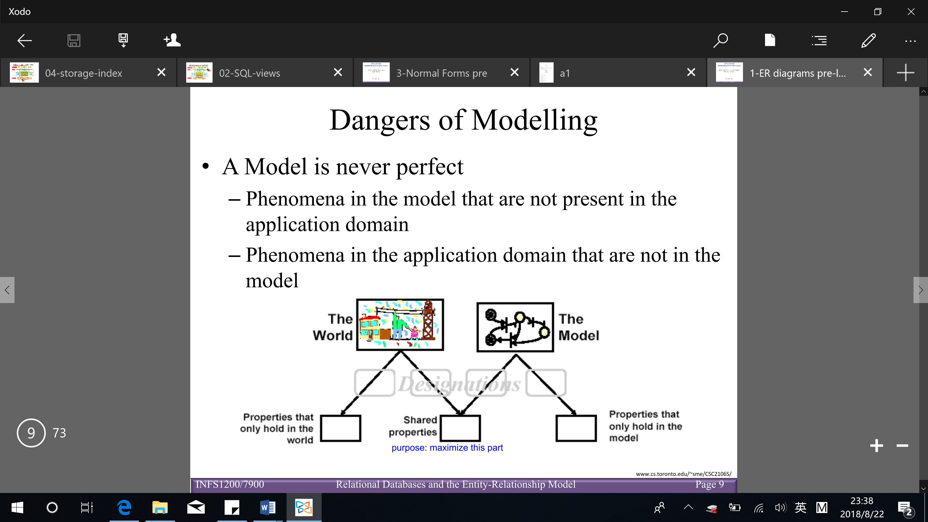

**Entity-relationship (ER) diagram**: a graphical data modeling technique that represents the main entities and their corresponding relationships within a system or an enterprise

(Help define business processes and are used as the foundation for a developing conceptual database designs)

Basic constructs:

* **Entity**: real-word object distinguishable from other objects (an entity is described using a set of attributes)

The same entity may have different prominence in different UoDs

Entity type: defines set of entities that have the same attributes (each entity type is described by its NAME and attributes)

* + Each attribute has a domain (e.g. float, integer, string, date)
  + Each entity set has a key

Entity set: the collection of all entities of a particular entity type in the database at any point in time

* **Attributes**
  + Key attributes

**Key**: the minimal set of one or more attributes which, taken collectively, identify uniquely an entity in an entity set

**Primary key**: the key chosen as the principal means to identify entities in an entity set (only primary keys are shown in ER diagrams)

* + Derived attributes: some attribute values can be derived from attributed values of related entities
  + Null valued attributes: a particular entity may not have an applicable value for an attribute

Type of Null values:

* Not applicable
* Unknown
* Missing
  + Composite V.S. simple attributes

Composite attributes can be divided into smaller parts which represent simple attributes with independent meaning

* + Multivalued V.S. single-valued attributes (simple attributes)
* **Relationship**: association among 2 or more entities

Relationship type: defines the relationship and a relationship set

Relationship set: represents the set of relationships of a particular type at any point in time (relationship set may have descriptive attributes)

Recursive relationships: same entity type can participate more than once in the same relationship type under different ‘role’

Relationship degree: the number of participating entity types

Binary relationship – 2 entities

Ternary relationship – 3 entities

N-ary relationship – n entities

(same entity type could participate in multiple relationship types)

**Relationship constraints**: constraints on the relationship type limit the possible combination of entities that may participate in the corresponding relationship set

Kinds of constraints (2):

* Cardinality constraint: for a relationship set specifies the number of relationships in the set that an entity can participate in
* One-to-one
* One-to-many

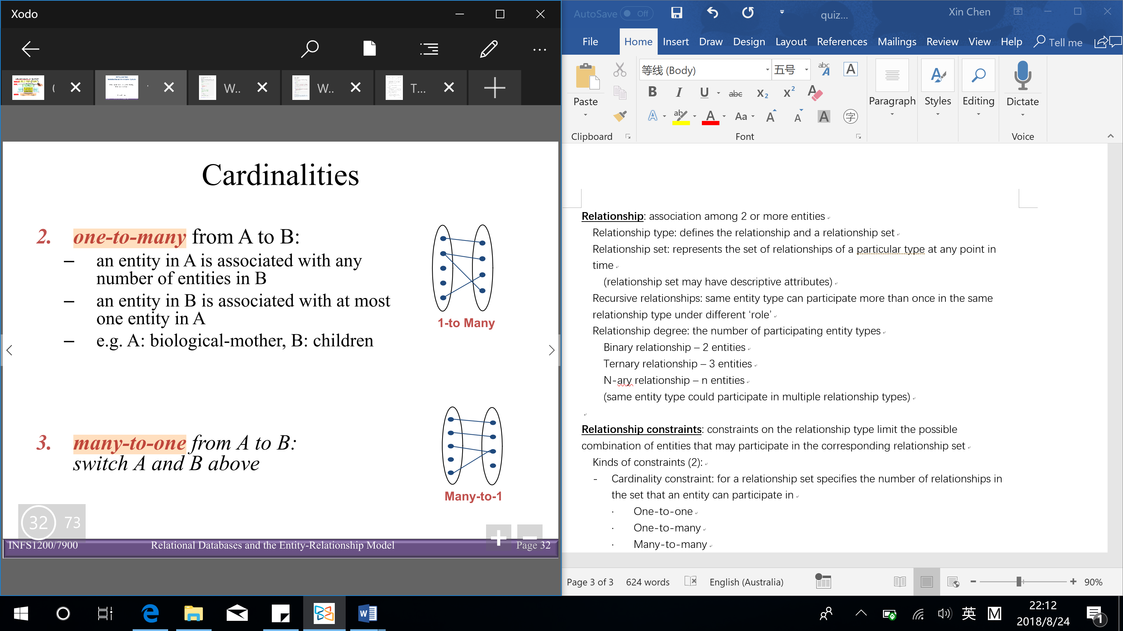

* Many-to-many

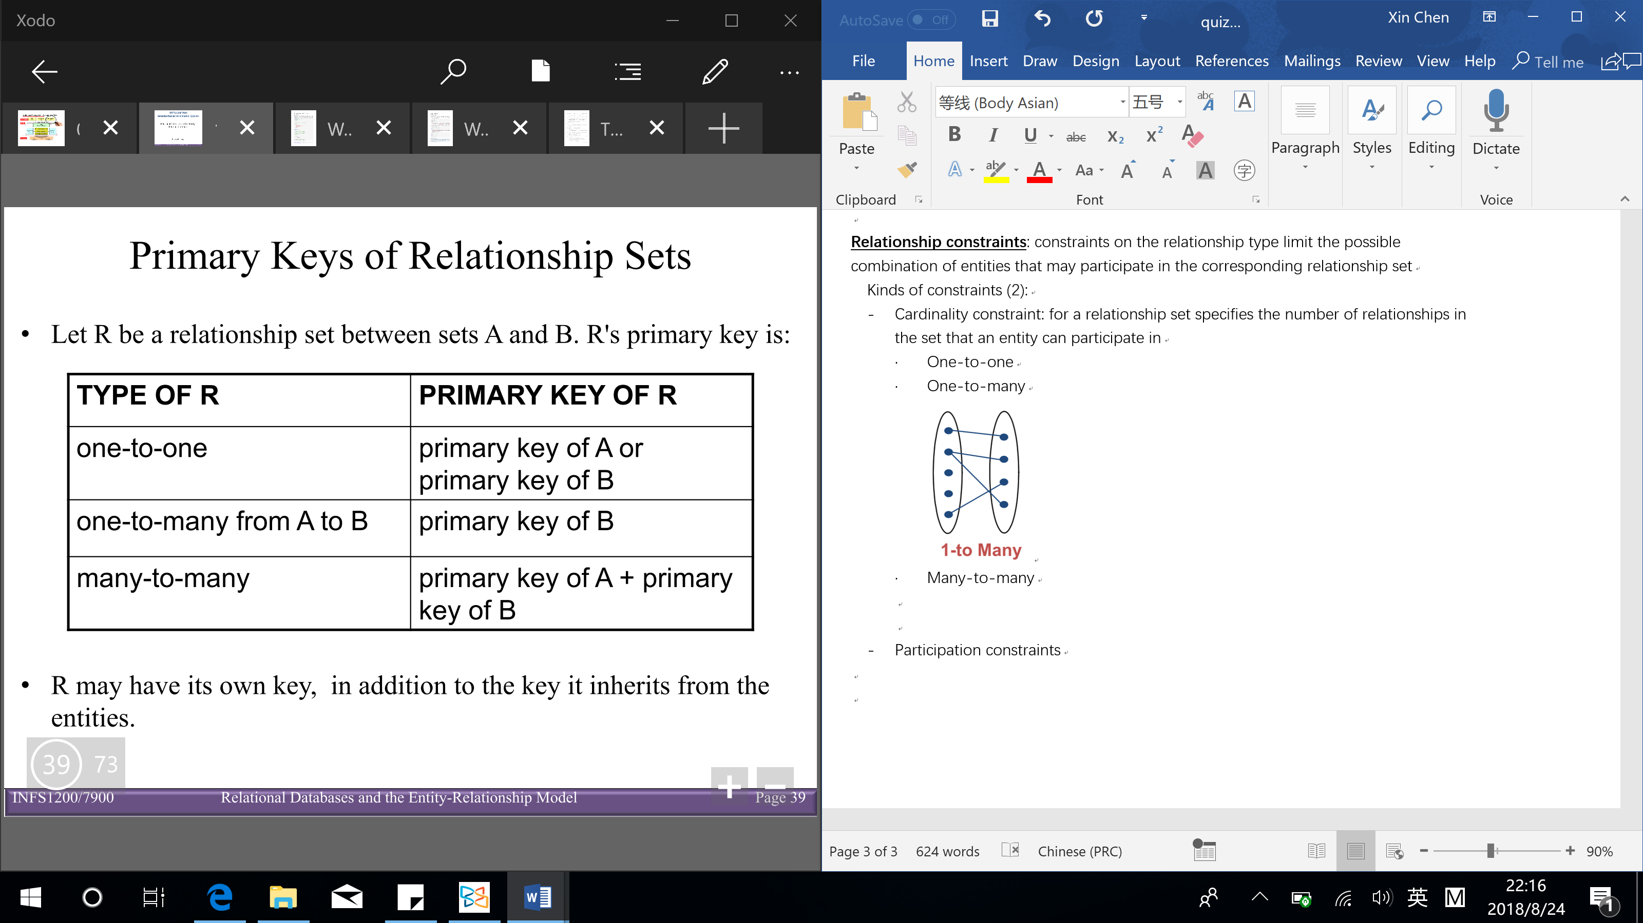(many side is primary key)

* Participation constraints: indicates if all entities participate in the relationship
* Total participation
* Partial participation
* **Weak entities**: can be identified uniquely only by considering the primary key of another (owner) entity [‘belongs to’ relationship]
  + Owner entity set and weak entity set must participate in a 1-to-many relationship set (one owner, many weak entities)
  + Weak entity set must have total participation in this identifying relationship set
* **Specialization & generalization**

**Specialization**:

* Define a number of subclasses of an entity type
* Each subclass contains a subset entities of the superclass
* A subclass is defined based on more specific distinguishing characteristic on entities of the super class

**Generalization**:

* Opposite process to specialization
* Abstraction process of ignoring differences amongst some entity types (subclasses) and generalize them into a superclass

【Subclasses are specializations of superclass & Superclass is generalization of subclasses】

Extended ER (EER)

* Entity type is called class in EER
* Class can be superclass, subclass
* Entities in the same class have the same attributes
* Attributes of a superclass are inherited by the subclasses
* Subclass can have its own specific attributes/ relationships
* Every entity in a subclass is a member of its superclass(es)

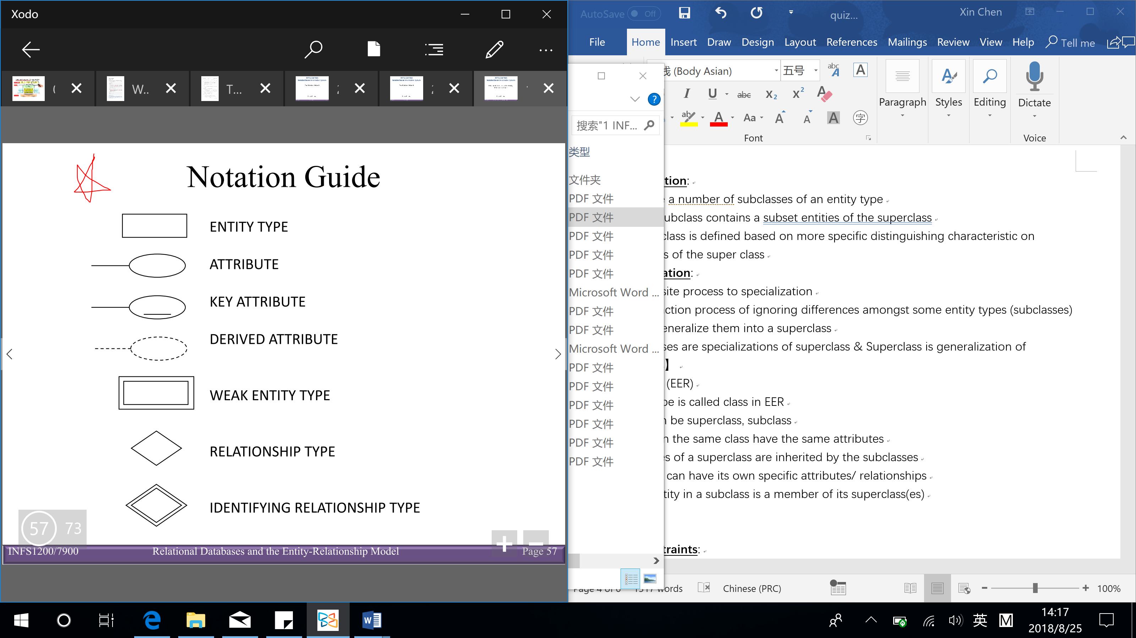 

**Integrity constraints**:

* Key constraints
* Participation constraints
* Overlap/ covering constraints for ISA relationships (subclass & superclass)
* Foreign key constraints

Data abstraction: an abstract view of data that excludes many details that are either too complex or not of interest to the users

Data model: a collection of concepts that can be used to describe the structure of a database to achieve data abstraction

* **Schemas**: the metadata or data describing data – static

(schemas is specified during database design, and is not expected to change frequently)

* **Instance**: the data in the database at a particular time – dynamic

(instances are created during data updates and change frequently)

**Relational model**

* Network model and databases – had a complex data model
* Hierarchical databases (similar to ER diagrams but fewer concepts) – integrated the application in the data model & disadvantage: query is too complicated
* Main concepts (4):
* Relations (R): the main construct for representing data in the relational model

A set of records (similar to a table with columns and rows BUT if it have something merge or combine columns or rows together is a table not a relation)

* Domains (D): a set of atomic values (each domain has a data type or format)

Popular domain types: integers, real numbers, fixed or variable length character strings, date, time stamp, currency, sub-range from a data type, enumerated data type

* Attributes (A): the name of a role played by some domain in the relation (degree of R: the number of attributes in a relation)
* Tuples (T): an ordered list of n values (relations are sets of tuples)

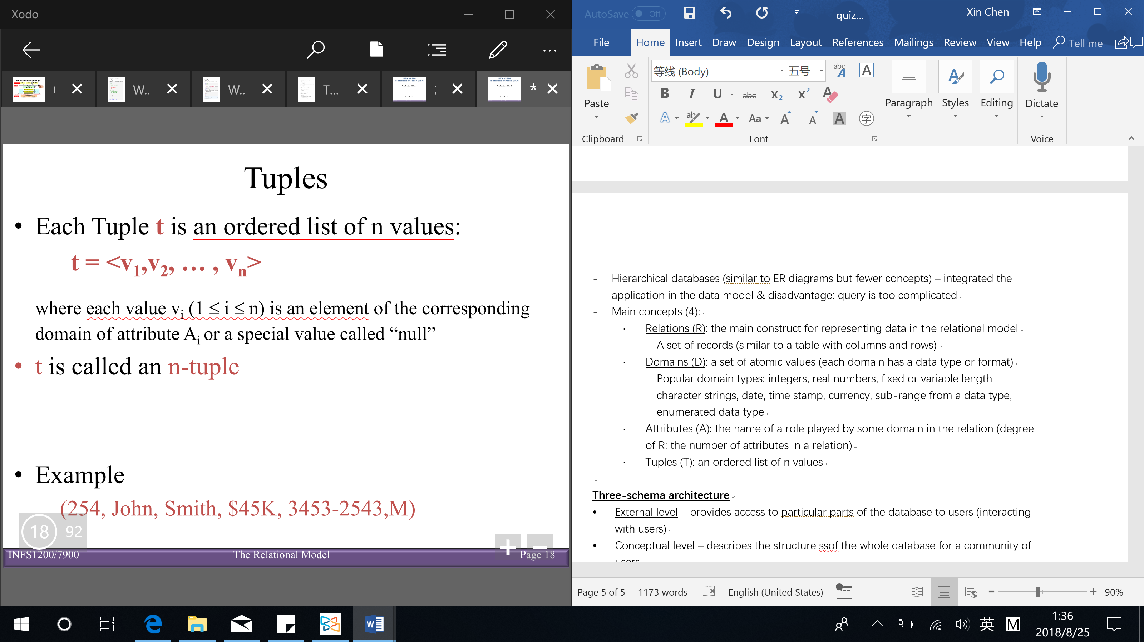

Ordering of tuples (order does not matter):

Mathematically, elements of a set have no implied order

Semantically, when reasoning with relations (e.g. formulating queries), order is irrelevant

Physically, tuples reside on blocks of secondary storage, which have a partial ordering, hence tuples have an ordering

Ordering of values within a tuple (n-tuple is an ordered list of n values) – ordering the attributes:

Syntactically, all tuples in a relation have values in the same order

Semantically, the order chosen is irrelevant, as long as the correspondence between the attributes and the values can be maintained (can swap the attribute and swap the values at the same time)

Relational database: a collection of relations with distinct relation names

Relational database design – process of capturing the semantics of an application, and translating it into a relational database schema

Relational schema: a set of schemas (attributes names) for the relations in the database

Relational instance: a set of n-tuples

**Three-schema architecture**

* External level – provides access to particular parts of the database to users (interacting with users)
* Conceptual level – describes the structure of the whole database for a community of users
* Internal level – describes the physical storage structure of the database

**Data independence**: ability to change the schema at one level of a database system without having to change the schema at the next higher level

* Logical data independence: ability to change the conceptual schema without changing applications
* Physical data independence: ability to modify physical schema without changing logical/conceptual schema

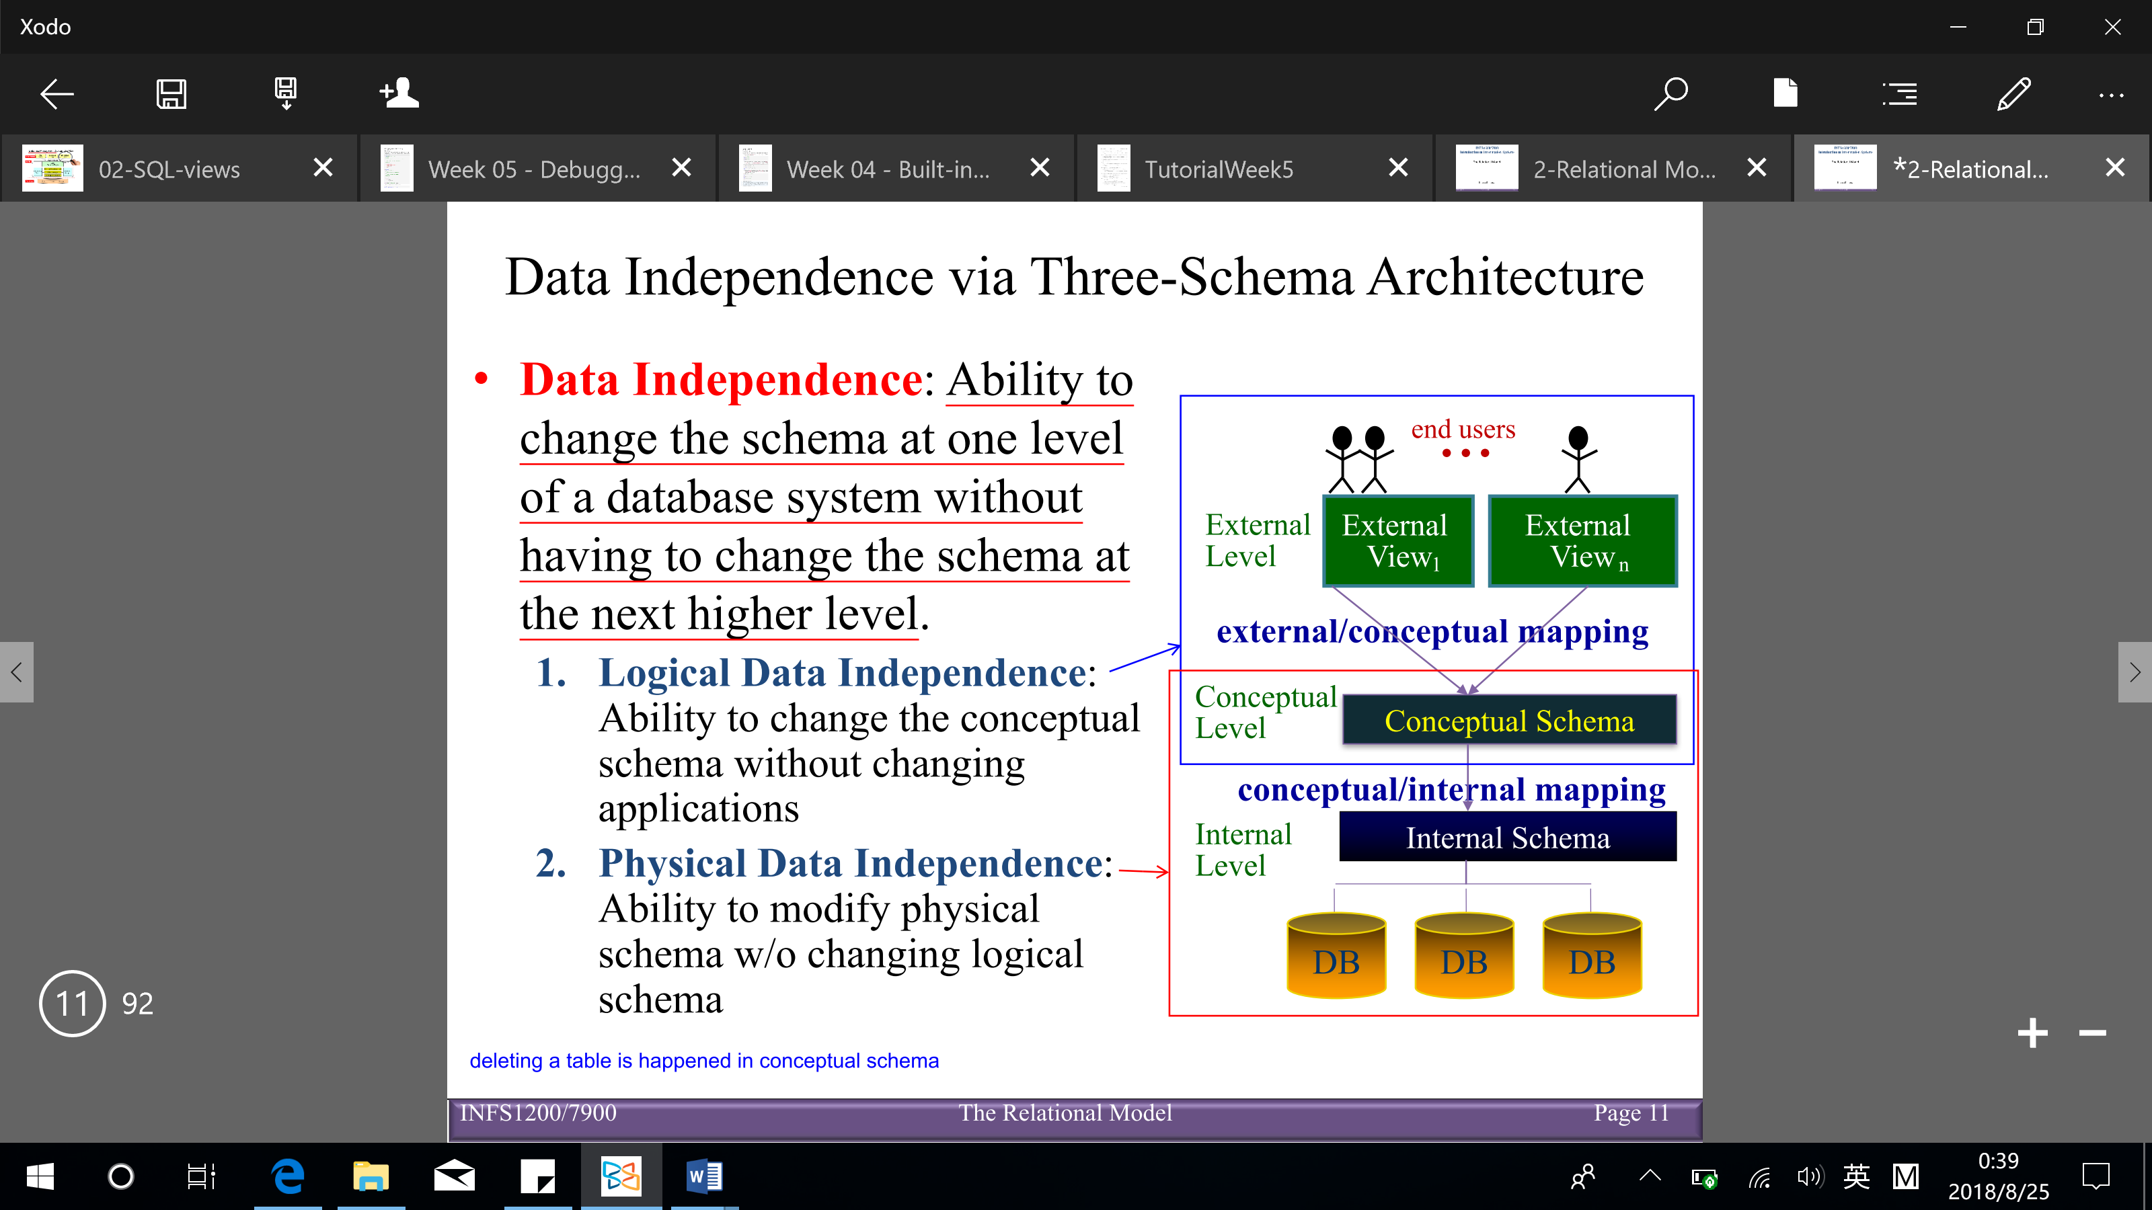

Implementation of constraints:

**Integrity constraints (ICs)**: conditions that must be true for any instance of the database

(IC is a statement about all possible instances)

* ICs are specified when schema is defined
* ICs are checked when relations are modified

A legal instance of a relation is one that satisfies all specified ICs

* DBMS should not allow illegal instances
* Avoids data entry errors

Types of ICs:

[sequence to check violation of ICs: primary key (Entity, Key), Domain, Referential]

* **Domain constraints**: each attribute in a relation must belong to some domain (right stuff is in the right spot)
* **Key constraints (uniqueness constraint)**: all tuples in a relation must be distinct, that is no 2 tuples can have same values for all attributes

Superkey (SK): subset of attributes that is uniqueness of a relation schema

(every relation has at least one Superkey – the set of all its attributes

$$t_{i} [SK] ≠ t_{j}[SK]$$

Superkey can have redundant attributes – by removing some attributes, the uniqueness constraint is still maintained)

Key (K): a minimal Superkey (minimal: removing any attribute means the proposed key is no longer a Superkey) – uniquely identify a tuple in a relation & key may have multiple attributes

A schema may have more than one key:

Candidate key

Primary key (PK) – only one is selected as PK

$$\left(Candiate key+Primary key\right)=Key \left(minimal superkey\right)⊆Superkey$$

* **Entity constraints**: no primary key (PK) can be null
* **Referential integrity constraints**: all foreign keys reference existing entities (data exists in the ‘parent’ before the ‘child’)

Specified between 2 relations and are based on the notion of foreign keys

Special situation: self referencing relations

Foreign keys: relate 2 different schemas – a set of attributes FK in relation $R_{1}$ is a foreign key if: $t_{1}\left[FK\right]=t_{2}\left[PK\right] or t{}_{1}\left[FK\right] is null$ (the attributes of FK have the same domain as the PK attributes of another schema $R_{2}$)

Deletion: child table → can just delete & parent table → need to check referential integrity

Modify: opposite of deletion

* **User-defined constraints**: general user defined constraints that cannot be enforced by the other constraints

Implemented by using: checks, assertions and triggers

(key and foreign key ICs are shown on ER diagrams/ conceptual model)

**Mapping ER diagrams to relational models**

Conceptual perspective:

* Conceptual design – the Entity Relationship (ER)
* Logical design (mapping) – the relational model

Mapping (ER diagram → relational model) steps (8):

【remember to add foreign key/ reference】

1. Entity

Include all simple attributes of a strong entity (break the composite attributes into simple attributes) & Choose one key attribute as primary key (PK)

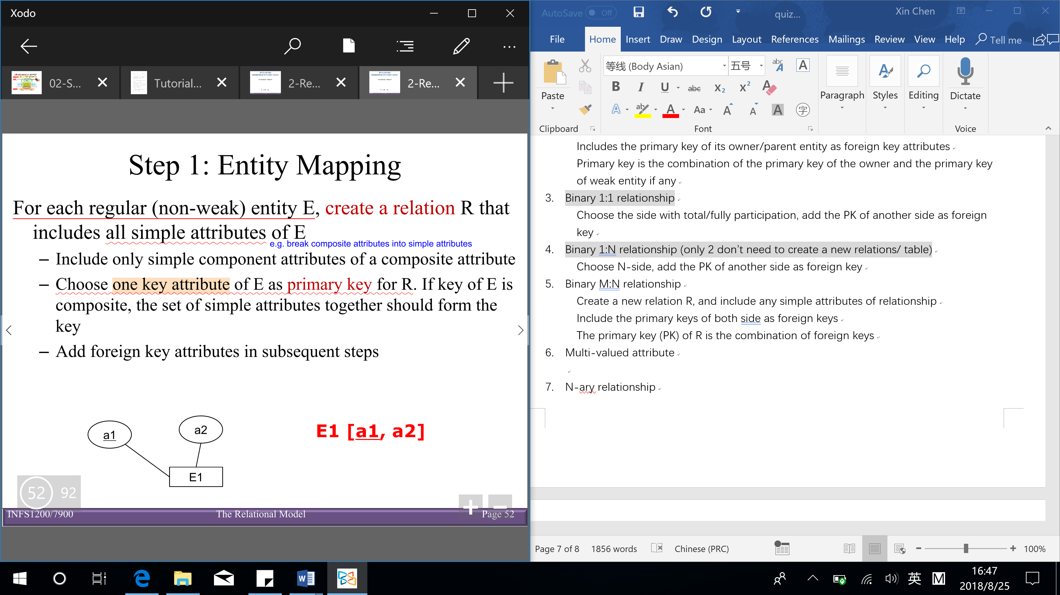

1. Weak entity

Includes all simple attributes of weak entity

Includes the primary key of its owner/parent entity as foreign key attributes

Primary key is the combination of the primary key of the owner and the primary key of weak entity (if any)

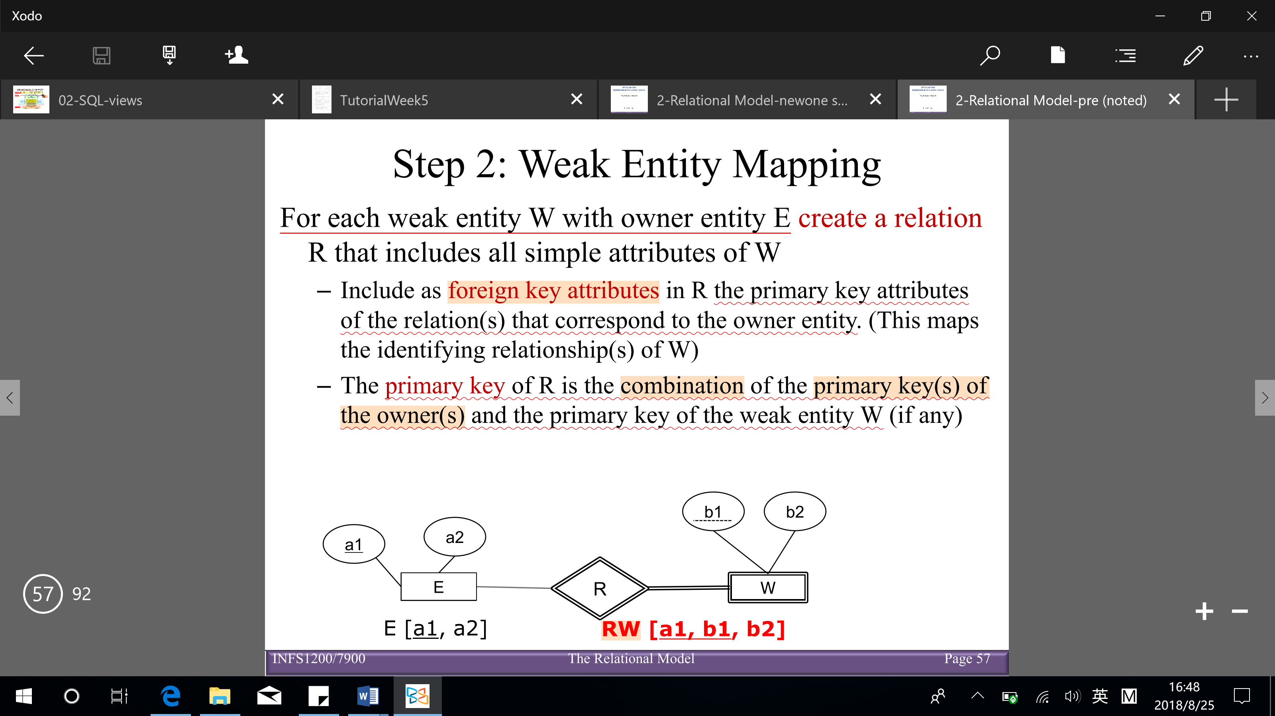

1. Binary 1:1 relationship

Choose the side with total/fully participation, add the PK of another side as foreign key

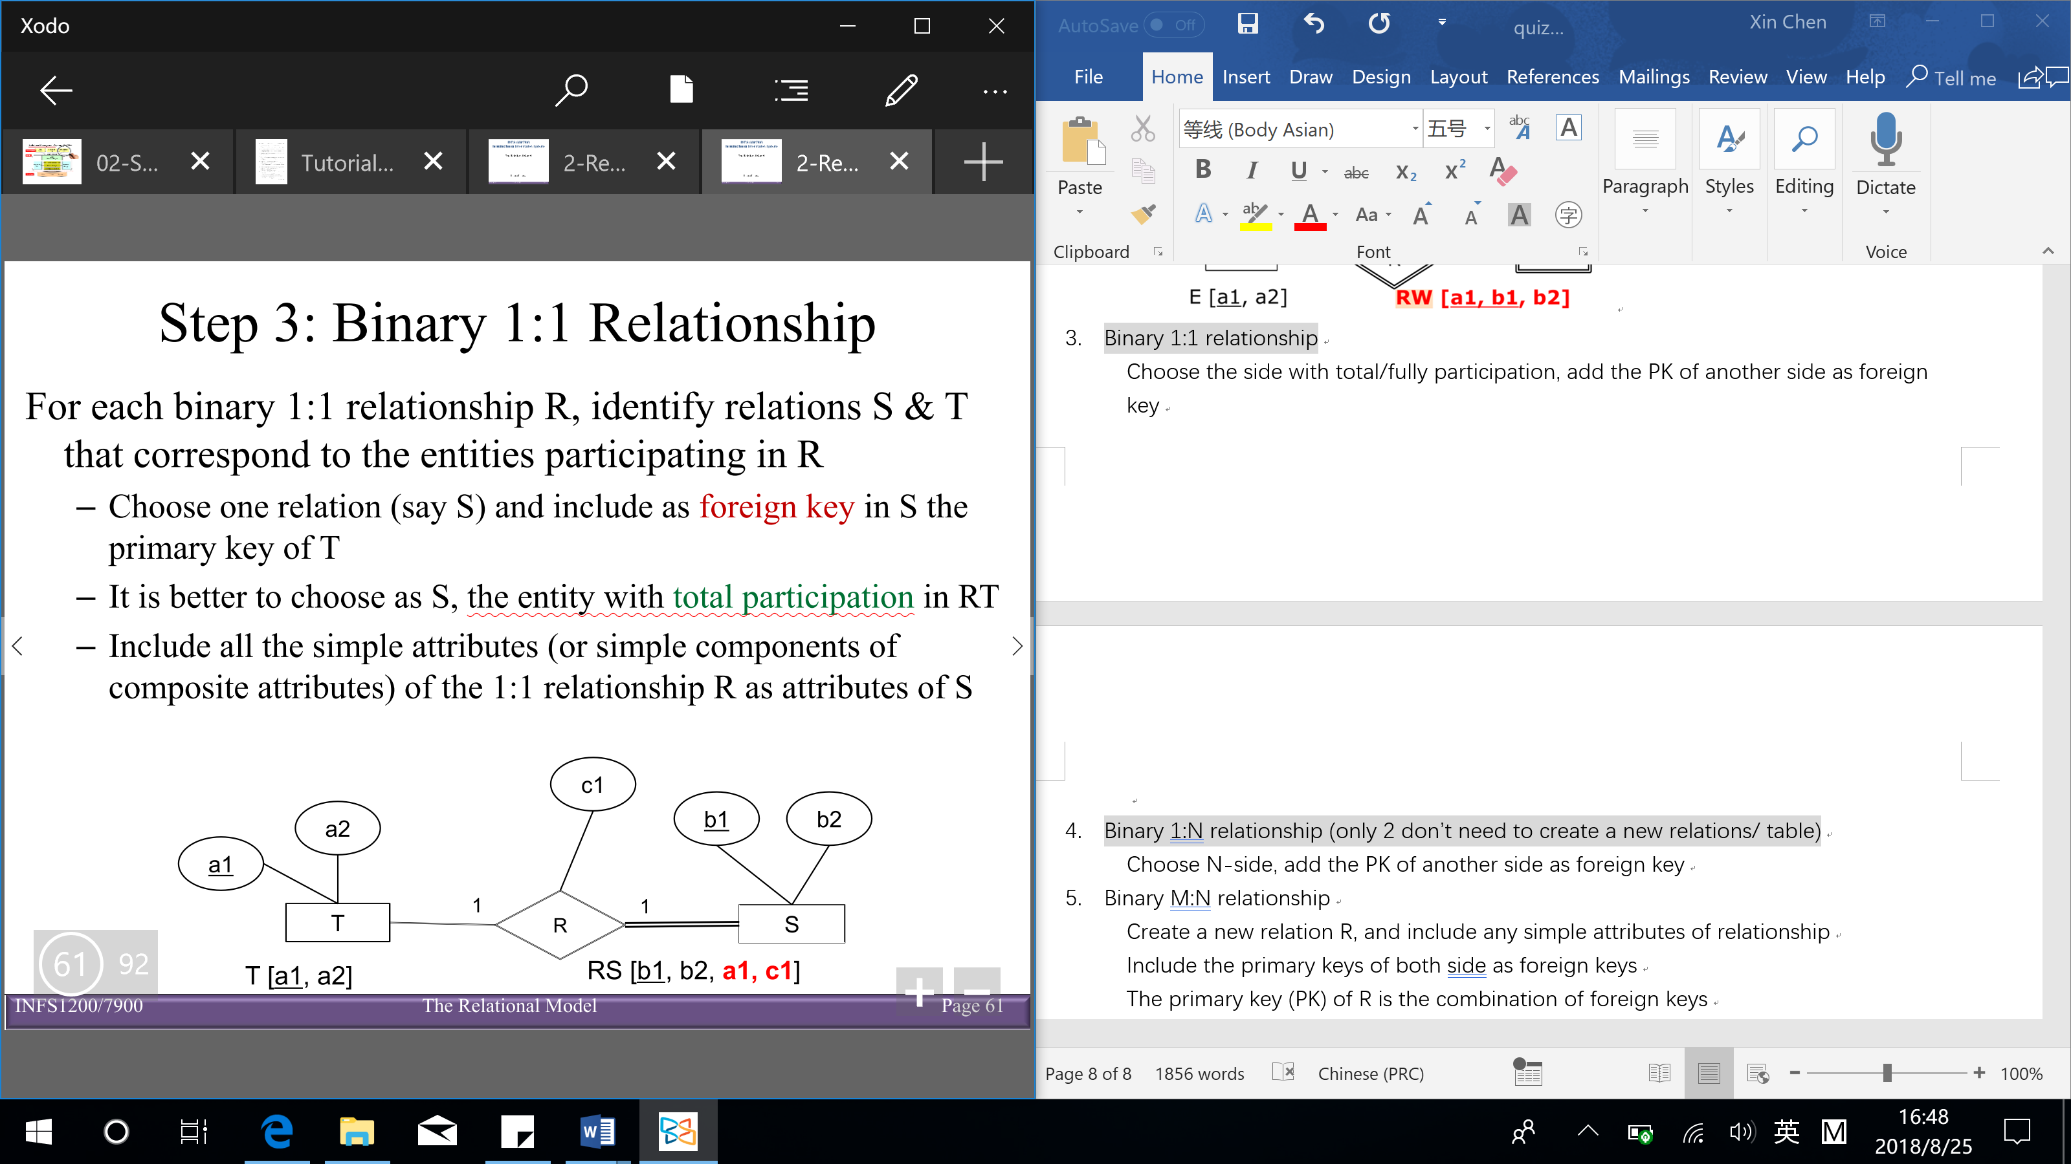

1. Binary 1:N relationship (only 2 don’t need to create a new relations/ table)

Choose N-side, add the PK of another side as foreign key

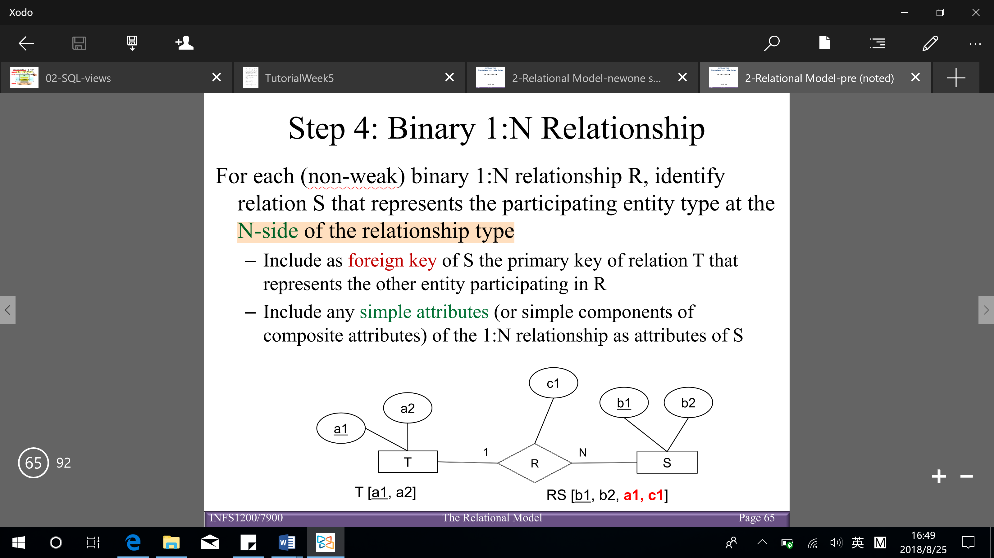

1. Binary M:N relationship

Include any simple attributes of relationship

Include the primary keys of both side as foreign keys

The primary key (PK) of R is the combination of foreign keys

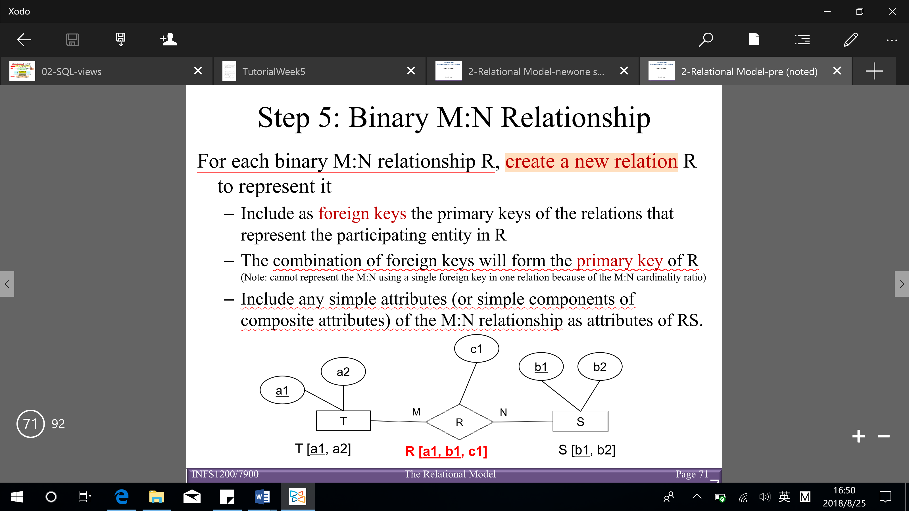

[Notice: 1:1, 1:N can map in the same way as M:N → advantage: reduces the number of ‘null’ that appear as foreign key values]

1. Multi-valued attribute

Includes that multi-value attribute and primary key (PK) of the entity as primary key (PK) → don’t have non-key attribute (ways to distinguish with weak entity: weak entity have other non-key attribute)

If the multi-valued attribute is composite, include its simple components

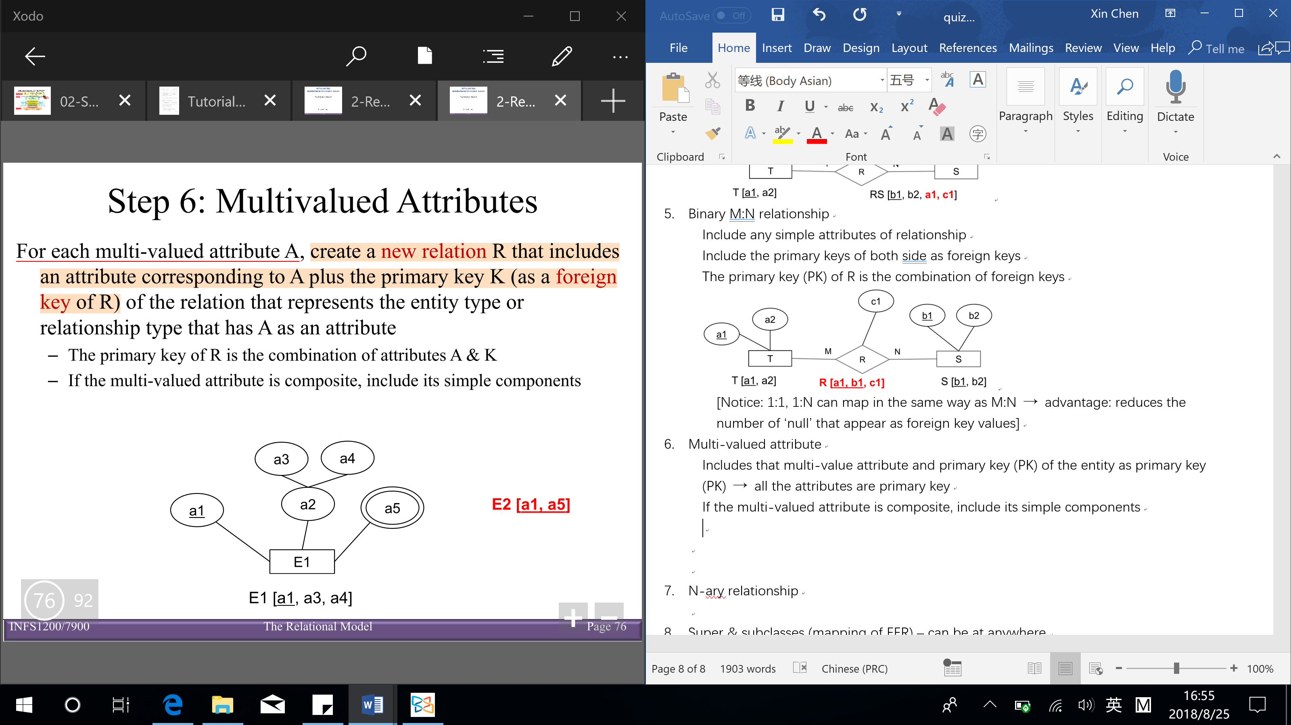

1. N-ary relationship

Include the primary key of all sides as foreign key

The combination of foreign keys (with many side relationship) is primary key (PK)

Include any simple attributes of n-ary relationship

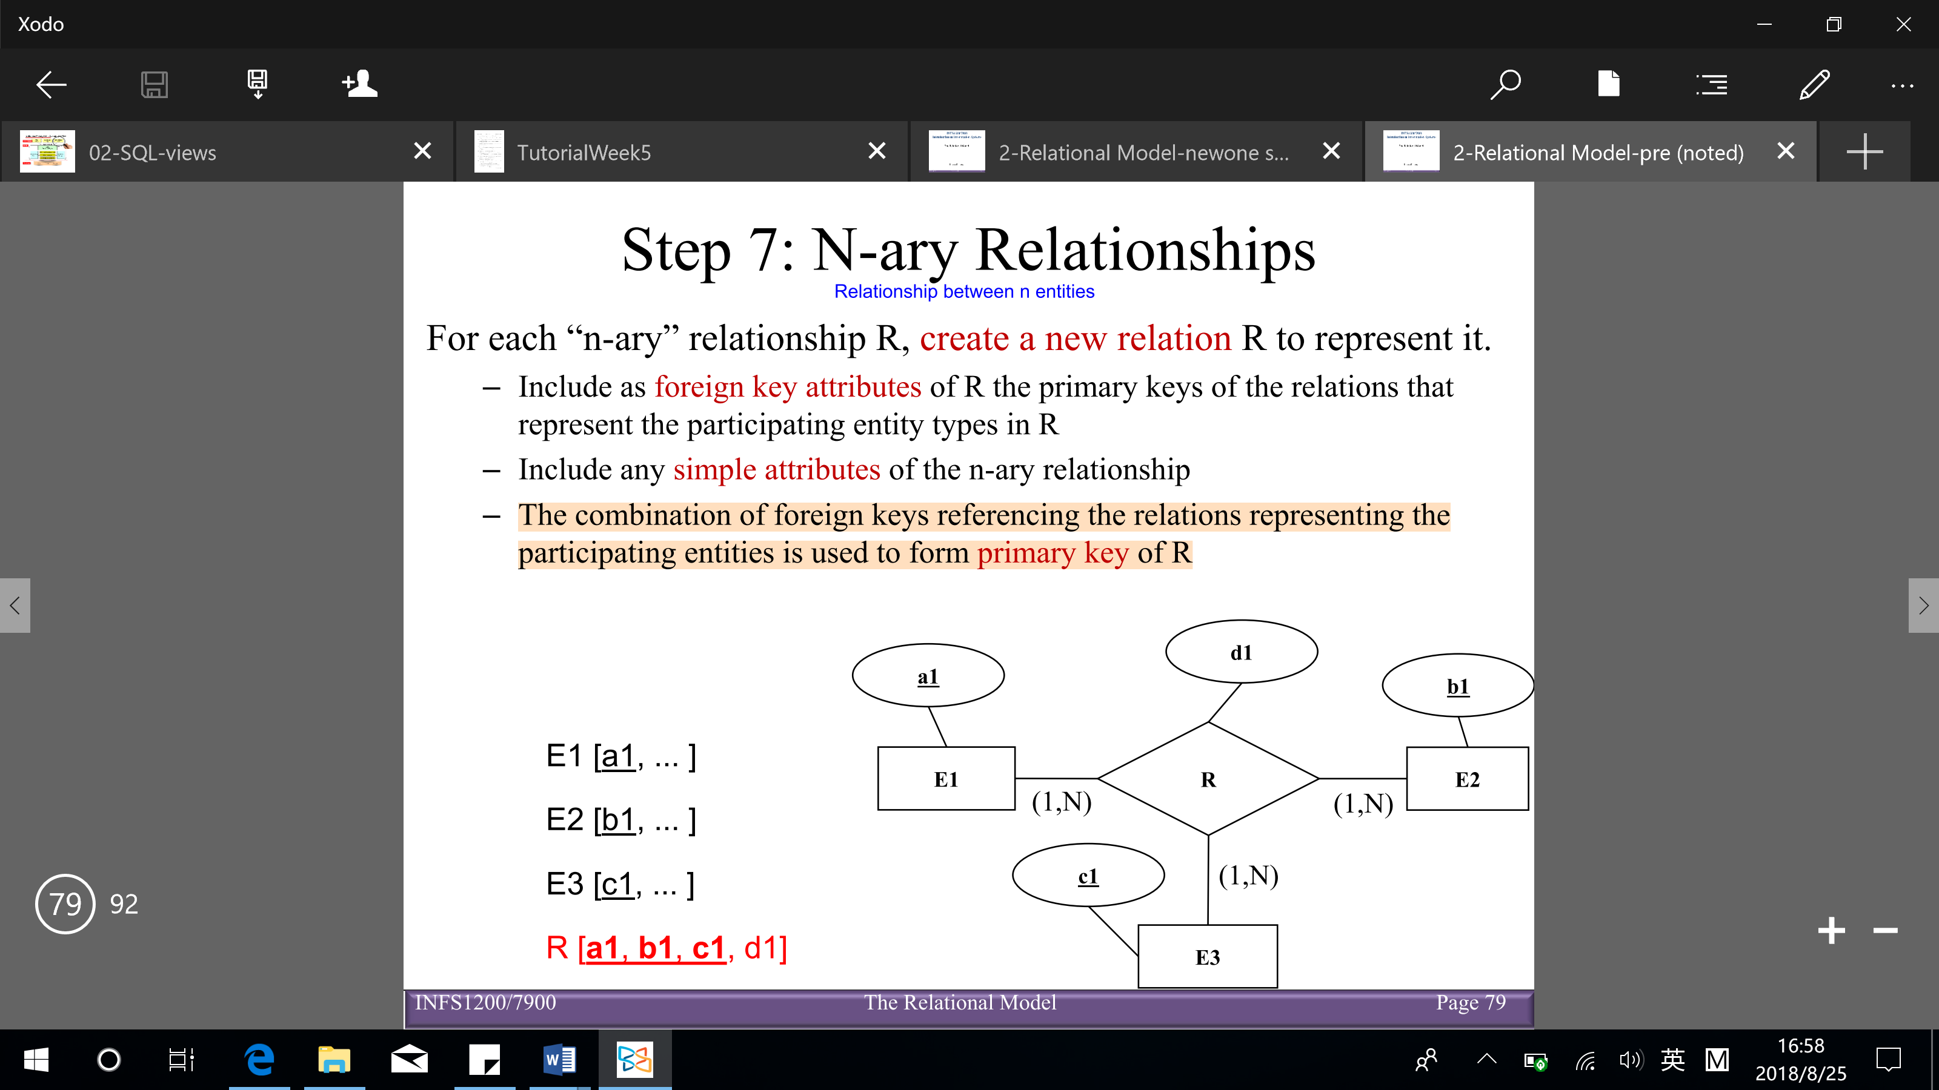

1. Super & subclasses (mapping of EER) – can be at anywhere

Create a relational table for the superclass

Create a relational table for each subclass

The primary key (PK) of each subclass is the primary key of the superclass (it also is the foreign key)

**Reverse engineering (from schema/ relational model to ER diagram)**:

1. Identify strong entities

The primary key (PK) has no foreign keys referencing → strong entity

1. Weak entities

If primary key (PK) is combining an existing primary key (via foreign key link) & it has additional non-key attributes → weak entity

1. 1:1 or 1:N relationships

Have foreign key reference that is non-key attribute → 1:1 (1 side) or 1:N (n side) relationship

1. M:N relationships

The primary key (PK) is a combination of existing primary key (via foreign key links)

1. Multi-valued attributes

The primary key combines an existing primary key (via foreign key link) & adds new attributes to the key

Have NO additional non-key attributes

1. N-ary relationships

The primary key (PK) is combination of existing of more than 2 primary keys

1. Super and subclasses

A relation/ table has the same primary key (PK) as an entity (via foreign key link)

**Design guidelines**

Informal design guidelines

* Semantics of the attributes

Design each relation so that it’s easy to explain its meaning

Do not combine attributes from multiple entity types and relationship types into a single relation

* Reducing the redundant values in tuples (minimize the storage space) & reducing the null values in tuples
* Disallowing spurious (fake/ false) tuples – when join and decomposition

Modification anomaly: data inconsistency that results from data redundancy

Deletion anomaly: loss of certain attributes because of the deletion of other attributes

Insertion anomaly: lack of ability to insert some attributes without the presence of other attributes (key cannot be null – entity constraint)

Incorrect grouping may cause update anomalies which may result in inconsistent data or even loss of data

**Decomposing a relation** (one table to many tables) – replace the relation R by 2 or more relations such that:

Each new relation contains a subset of the attributes of R (and no attributes not appearing in R)

Every attribute of R appears in at least one new relation

**Join**: $R_{1}⋈R_{2}$ is the (natural) join of the 2 relations – each tuple of $R_{1}$ is concatenated (link together in a chain or series) with every tuple in $R_{2}$ having the same values on the common attributes

Lossless-join decompositions: decomposition of $R$ into $R_{1}$ and $R_{2}$ is a lossless-join with respect of a set of functional dependences F if, for every instance r that satisfies F: $R=R_{1}⋈R_{2}$ (If we break a relation R, into bits, when we put the bits back together, we can get the exactly R back again)

Lossy-join decomposition (loss – loss of information OR addition of spurious information) – we try to avoid this situation

**Functional dependencies (FD)** – one attribute determines another attribute: $x→y$ holds if for every legal instance, for all tuples $t_{1},t_{2}$: if $t_{1}.x=t_{2}.x→t_{1}.y=t_{2}.y$

(means that given 2 tuples in r, if the x values agree, then y values must also agree)

Key: a minimal set of attributes that functionally determines all the attributes

Superkey: a relation uniquely identifies the relation, but does not have to be minimal

Explicit and implicit FDs:

Given a set of (explicit) functional dependencies, we can determine/imply implicit ones

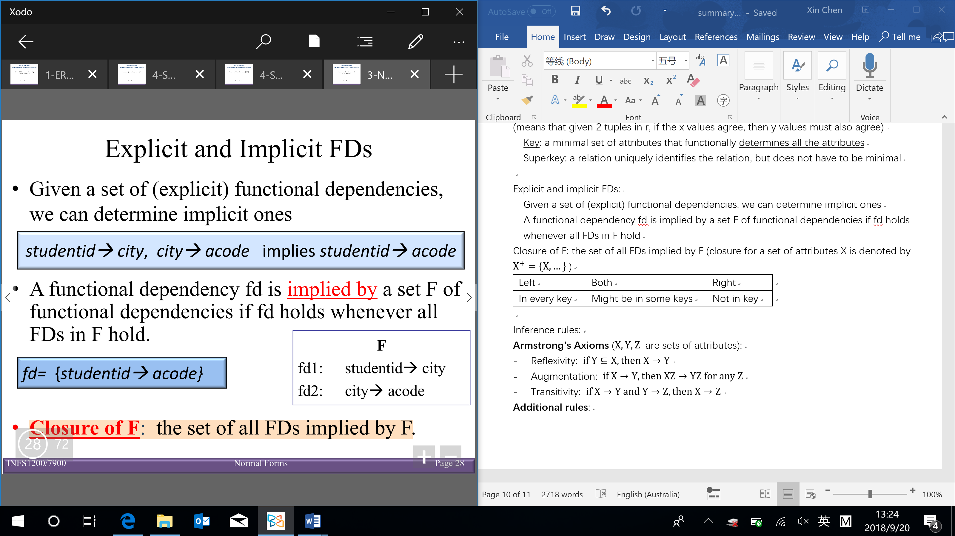

A functional dependency fd is implied by a set F of functional dependencies if fd holds whenever all FDs in F hold

Closure of F: the set of all FDs implied by F (closure for a set of attributes X is denoted by $X^{+}=\left\{X, …\right\}$)

|  |  |  |
| --- | --- | --- |
| Left | Both | Right |
| In every key | Might be in some keys | Not in key |

Inference rules:

**Armstrong’s Axioms** ( $X,Y,Z$ are sets of attributes):

* Reflexivity: $if Y⊆X, then X→Y$
* Augmentation: $if X→Y, then XZ→YZ for any Z$
* Transitivity: $if X→Y and Y→Z, then X→Z$

**Additional rules**:

* Union: $if X→Y and X→Z, then X→YZ$
* Decomposition: $if X→YZ, then X→Y and X→Z$

Role of FDs in detecting redundancy (suppose 3 attributes, A, B, C):

* No FDs hold: there is no redundancy here
* Given A → B: several tuples could have the same A value, and if so, they’ll all have the same B value

**Normalization**: the process of removing redundancy from data

### before quiz 1